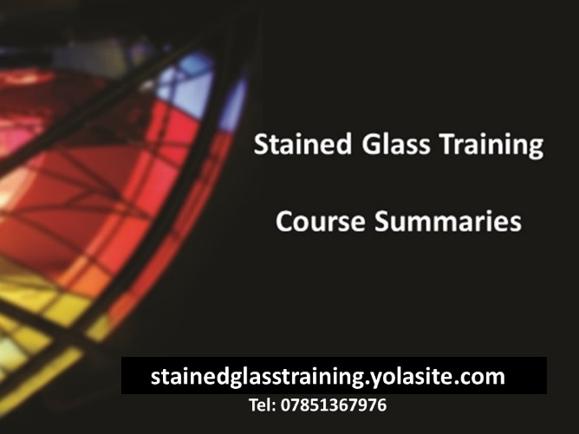
‘Taster Day’ - Introduction to basic Stained Glass Techniques (coloured glass NOT glass painting)
… suitable for total beginners who wish to gain basic skills and understand scope of skills to learn.
What you will learn
This course introduces the basic skills required in the traditional craft of Stained (coloured) Glass. At the end of the course you will have designed and built at least 2 x A5 Tiffany light catchers and have the confidence and knowledge to continue at home. You will, in addition, be introduced to the traditional stained glass making method of using lead came which is the subject of a further day course.
No previous experience is required as we will cover pattern making, glass cutting, foiling, soldering, patination and polishing during the course. You will also be advised on the equipment required to enable you to continue at home.
Course Structure
The course is run by Paul Hollis who has over 30 years experience in stained glass work. He runs his own stained glass commissions and training studio (stainedglasstraining.yolasite.com) and mentors a local youth ‘stained glass cooperative venture’ (contemporarystainedglass.yolasite.com)

The course is held at the studio near Lingfield, Surrey.
Each course has a maximum of 5 people which provides ample opportunity for individual attention. You will need to bring a sturdy soled pair of covered shoes (to resist glass chips on floor) and a packed lunch (microwave available if needed). Photos of project progress will be taken throughout the day, with your approval and a memento collage will be emailed to you.
Personal Suitability Considerations
Seating is provided but extended periods of standing will be required. Glass cutting requires average hand strength and dexterity. Pregnant ladies should not attend. Safety awareness will be discussed and safety equipment made available for your use. Workshop access is via a short grass incline and shallow steps.
Price
£120 inclusive of all materials and unlimited tea/coffee.

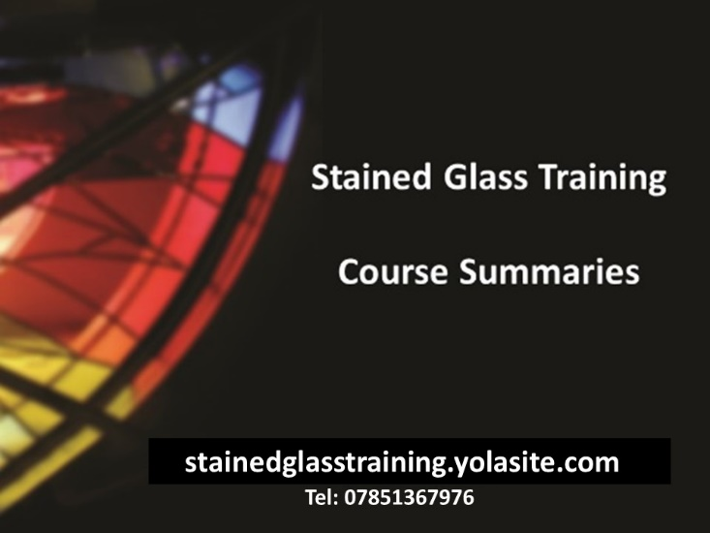
‘Project Day’ - Introduction to Leaded Lights (coloured glass NOT glass painting)
.. students should have basic skills covered by our ‘Introduction to Stained Glass Techniques’ course.
What you will learn
This course introduces the traditional craft of Leaded Stained (coloured) Glass. At the end of the course you will have designed and built your own A4 sized leaded panel from scratch and have the confidence to continue at home.
The course will cover: Design Limitations/considerations, Cartoon production, project layout, glass cutting, lead came cutting, jointing, soldering, framing, cleaning, patination, polish.
Course Structure
The course is run by Paul Hollis who has over 30 years experience in stained glass work. He runs his own stained glass commissions and training studio (stainedglasstraining.yolasite.com) and mentors a local youth ‘stained glass cooperative venture’ (contemporarystainedglass.yolasite.com)

The course is held at the studio near Lingfield, Surrey.

Each course has a maximum of 5 people which provides ample opportunity for individual attention. You will need to bring a sturdy soled pair of covered shoes (to resist glass chips on floor) and a packed lunch (microwave available if needed). Photos of project progress will be taken throughout the day, with your approval and a memento collage will be emailed to you.
Personal Suitability Considerations
Seating is provided but extended periods of standing will be required. Glass cutting requires average hand strength and dexterity. Pregnant ladies should not attend. Safety awareness will be discussed and safety equipment available for your use. Workshop access is via a short grass incline and shallow steps.
Price
£120 inclusive of all materials and unlimited tea/coffee

_____________________________________________________________________________________

